

Last-Mile Delivery Operations Analytics
MySQL Business Analytics Project

Project Introduction
QuickRoute Logistics is a last-mile delivery company serving customers across multiple delivery areas. The company operates a delivery fleet and a team of drivers to fulfil customer orders. The Operations team wants to use data to understand delivery demand, customer behaviour, delivery performance, and resource utilization.
You will work as a Data Analyst supporting the Operations team. Your task is to understand the business, understand the data model, build the database, analyse the data using MySQL, and communicate meaningful business insights.

Sprint 1: Business Understanding and Data Understanding

1.1 Company Background
Understand the company's business, the nature of last-mile delivery operations, and the business context behind the analysis.

1.2 Role
Assume the role of a Data Analyst supporting the Operations team. Your responsibility is to use the available data to answer business questions and support operational decisions.

1.3 Understanding the ER Diagram
Study the ER diagram carefully before accessing the database. Understand the tables, columns, primary keys, foreign keys, and relationships.
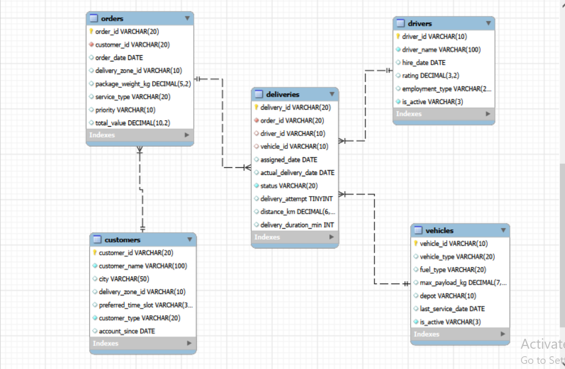
Figure 1: Last-Mile Delivery database ER diagram

1.4 Analytical Thinking from the ER Diagram
Before accessing the database or writing SQL queries, use the ER diagram to plan how you would investigate each business situation.
- Do not write SQL queries at this stage.
- For each situation, identify the tables and columns you would need.
- Explain how the required tables are related.
- Describe what information you would compare or examine and the logical flow you would follow.
1. Management wants to find customers who have placed multiple orders. What information would you need to identify them?
2. The Operations team wants to identify orders that required more than one delivery attempt. Where would you find the information needed to investigate this?
3. The Customer team wants to compare Business and Individual customers based on their ordering activity. Which tables and columns would you need?
4. The Operations team wants to compare different service types based on how far deliveries travel and how long they take. Which tables would you need to connect?
5. The team wants to identify which drivers have handled deliveries and examine their recorded ratings. What information would you need?
6. Operations wants to understand whether different types of vehicles are being used for different deliveries. Which tables and columns would you need?
7. Management wants to compare delivery performance across different delivery zones. What information would you need from the database?
8. The Operations team wants to investigate whether heavier packages are associated with longer delivery durations. Which information would you need, and where would you find it?
9. Management wants to understand whether delivery outcomes differ across service types. What tables and information would you bring together?
10. The Operations team wants to understand which customers have placed orders and how their orders are being handled. What information would you need to connect a customer with their orders and deliveries?

Sprint 2: Database Setup

2.1 Design the Database from the ER Diagram
Using the provided ER diagram as your blueprint, create the database and tables in MySQL. The table-creation queries are not provided.
- Choose appropriate data types.
- Define primary keys.
- Define foreign keys.
- Apply essential constraints such as NOT NULL, UNIQUE, and DEFAULT where appropriate.
- Create tables in an appropriate order based on their dependencies.

2.2 Data Import
Import the provided CSV files into the respective MySQL tables and verify that the data has been loaded correctly. MySQL Import Wizard may be used.

Dataset Overview
Table | Rows | Columns
customers | 400 | 7
orders | 3,000 | 8
deliveries | 3,500 | 10
drivers | 80 | 6
vehicles | 50 | 7

Sprint 3: Basic Analysis / Data Exploration
Write SQL queries to answer the following basic questions. The purpose of this sprint is to become familiar with the database before moving into objective-based analysis.
- What is the total number of customers?
- What is the total number of orders?
- What is the total number of deliveries?
- What are the different service types available?
- How many drivers are currently active?
- What are the different vehicle types?
- What is the total order value?
- What is the average package weight?

Sprint 4: Objective-Based Analysis
For each objective, understand the business requirement, formulate your own analytical questions, determine the required data, write multiple meaningful SQL queries, interpret the results, and record your business insights.

4.1 Understand Delivery Demand
Business Objective: The Operations team wants to understand where and how delivery orders are being generated.
Things to Consider While Analyzing:
- Compare the number of orders across delivery zones.
- Compare orders across different service types.
- Compare orders based on priority.
- Examine how order volume changes over time.
- Look at order value across different groups.
Formulate the analytical questions required to address the objective and support your analysis with multiple meaningful SQL queries. The points above are starting points, not predefined SQL questions.

4.2 Understand Customer Order Behaviour
Business Objective: The Customer team wants to understand how customers are using the delivery service.
Things to Consider While Analyzing:
- Compare customers based on the number of orders they place.
- Identify customers with higher total order value.
- Compare customer activity across delivery zones.
- Look at differences between business and individual customers.
- Examine customer ordering patterns over time.
Formulate the analytical questions required to address the objective and support your analysis with multiple meaningful SQL queries. The points above are starting points, not predefined SQL questions.

4.3 Evaluate Delivery Performance
Business Objective: The Operations team wants to understand how well deliveries are being completed.
Things to Consider While Analyzing:
- Compare delivery outcomes across different zones (zone information is on the orders table, so you will need to connect orders and deliveries).
- Examine delivery duration.
- Compare delivery outcomes by status (Delivered, Failed, Pending, Rescheduled) — these are not a simple success/failure split, so consider what each status actually represents.
- Identify areas with higher delivery activity or poorer outcomes.
- Compare delivery performance over time.
Formulate the analytical questions required to address the objective and support your analysis with multiple meaningful SQL queries. The points above are starting points, not predefined SQL questions.

4.4 Understand Driver and Vehicle Performance
Business Objective: The Operations team wants to understand how its delivery resources are being utilized and how they are performing.
Things to Consider While Analyzing:
- Compare the number of deliveries handled by drivers.
- Compare driver performance across delivery outcomes.
- Examine delivery duration across drivers.
- Compare vehicle usage across different vehicle types.
- Look at delivery performance across different vehicles.
Formulate the analytical questions required to address the objective and support your analysis with multiple meaningful SQL queries. The points above are starting points, not predefined SQL questions.

4.5 Identify Delivery Problems
Business Objective: The Operations team wants to understand why some deliveries require additional effort or fail to complete successfully.
Things to Consider While Analyzing:
- Examine which deliveries required multiple attempts before succeeding.
- Identify common delivery statuses and problem patterns.
- Compare delivery performance for orders with multiple attempts.
- Examine whether certain zones experience more delivery problems.
Formulate the analytical questions required to address the objective and support your analysis with multiple meaningful SQL queries. The points above are starting points, not predefined SQL questions.

SQL Deliverable
- ER diagram interpretation and Sprint 1.4 logical solutions.
- MySQL database created from the provided ER diagram.
- Imported and verified project data.
- SQL queries for Sprint 3.
- Your analytical questions for each Sprint 4 objective.
- Supporting SQL queries for each objective.
- Findings and business insights.
- Final conclusions and recommendations wherever appropriate.

Final Outcome
By completing this project, you should be able to move from a business requirement to a data-driven answer: understand the business problem, reason from a data model, plan an analytical solution, build a relational database, formulate questions, write SQL queries, interpret results, and communicate meaningful business insights.

